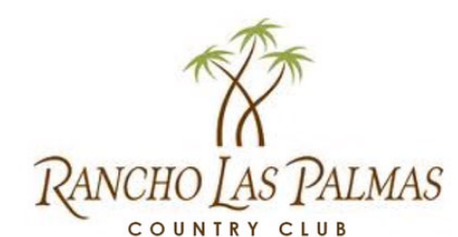
RANCHO LAS PALMAS MEN’S AND LADIES GOLF ASSOCIATION
2024 – 2025 Tee Flag Form

NAME: ___________________________________________________
PHONE NUMBER: __________________________________________
EMAIL: ___________________________________________________
I would like my Sponsor’s Flag to read (please print clearly):
_________________________________________________________
_________________________________________________________
_________________________________________________________
_________________________________________________________
Please select: USA Flag: ___ Canadian Flag: ___ Other Country Flag/Name: ________________
Select to include both an American and Canadian Flag: ___
Check to include custom logo ___ ($50 extra if new logo) Name: ______________________
Check to indicate New Regular Flag Sponsor ($250) ______ Re-use Last Years Flag ($225) _______
Check to indicate Gold Flag Sponsor ($500) ____
Total Cost of Your Flag ______________
Please return this form along with your check payable to:
Rancho Las Palmas Men’s Club
Please either drop off in the Men’s Club mail box at the clubhouse; mail or Email to the address below.
Randy Barnes
1 Ivy League Circle
Rancho Mirage, CA 92270
Rcb758@aol.com

Many thanks for your support!
Respectfully, your Member at Large – Randy Barnes

